**535/1**

**PHYSICS**

**PAPER 1**

**JULY/AUGUST**

**2 ¼ HOURS**



**ELITE EXAMINATION BUREAU MOCK 2019**

**Uganda Certificate of Education**

**PHYSICS**

**PAPER 1**

**Corrigendum**

3. Fig 1 shows a uniform meter rule XY which balances when a mass of 40g is hung 0.4m from the knife edge.

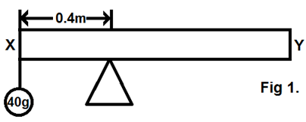

Calculate the mass of meter rule

A. 160g B. 100g C. 120g D. 220g

**END**